Write a program of Missionaries and Cannibals using python code

Aim :To solve the Missionaries and Cannibals problem using Python.
Procedure:
Represent the number of missionaries and cannibals on the left bank.
Move people across the river using a boat of capacity 2.
Ensure cannibals never outnumber missionaries on either bank.
Use Breadth-First Search (BFS) to find a valid sequence of moves.
Print the steps from the start state to the goal state.

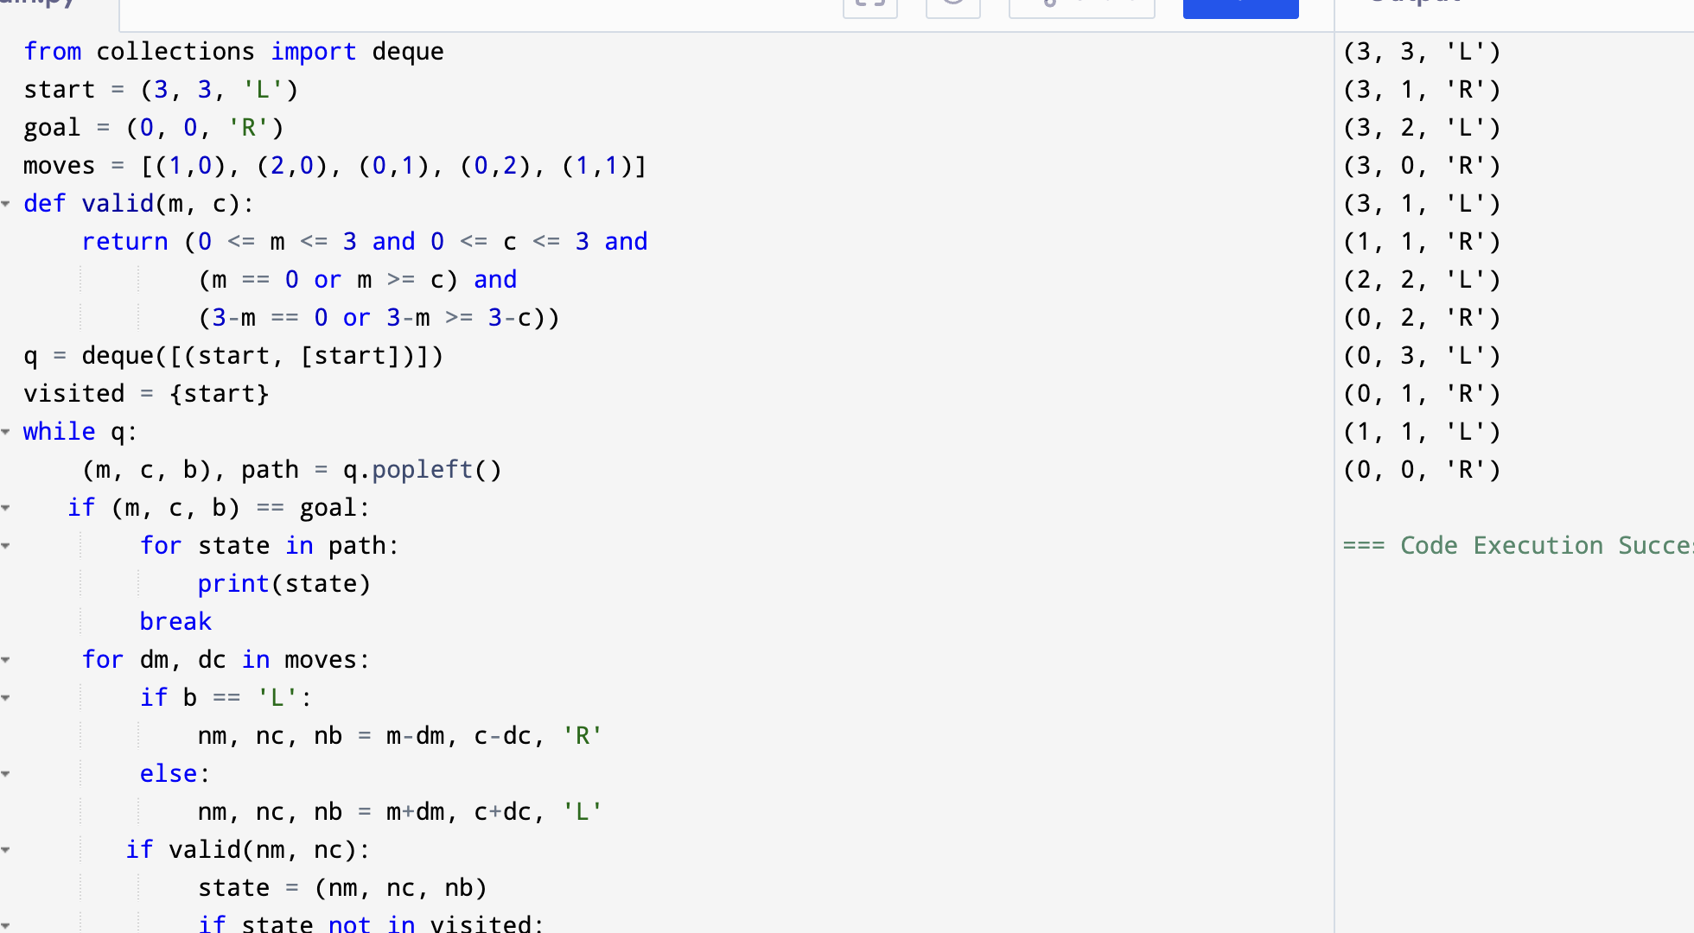
Output:

Result: Hence, Missionaries and Cannibals problem has solved

